Visual Thinking in Multimodal Artificial Intelligence: Evidence, Observability, and Opportunities for Human–AI Reasoning Interfaces
Research review and proposed experimental framework | October 8, 2026
Nathan Conklin
nathan.conklin@vt.edu
Department of Computer Science,
Virginia Tech

Abstract
Multimodal foundation models process text, images, video, and audio through learned numerical representations. Some systems also use intermediate visual artifacts to guide inference, including drawings, annotated images, image transformations, simulated states, and learned visual tokens. Recent work shows that these mechanisms can improve performance on particular spatial and perception-intensive tasks. The literature also identifies substantial limits. Visual chain-of-thought (CoT) does not consistently outperform textual CoT; language-based reasoning can degrade spatial performance; and the production of intermediate images is insufficient evidence that a model causally used those images to arrive at its answer. This review synthesizes research published from 2024 through October 2026, examines accessible models, APIs, and observability products, and proposes an instrumented human–AI reasoning workspace that connects model-visible statements to images, tool operations, and provenance. The proposed evaluation separates generated explanations from model-observed artifacts and tests whether visual steps contribute causally to task outcomes. The contribution is a research framework for studying both machine use of intermediate visual representations and human understanding of the resulting execution trace.
Keywords: multimodal large language models, vision-language models, visual chain-of-thought, latent reasoning, visual scratchpads, interpretability, observability, human–AI interaction, provenance.

Introduction and Research Motivation
Current AI interfaces typically present prompts and generated answers as text, even when a model processes photographs, diagrams, video, or sound. Some interfaces expose a textual reasoning summary. Others display retrieved pages or a tool execution log. The user must connect these representations to understand how the system reached a result. The challenge becomes more pronounced when the model uses intermediate images, spatial features, or image-processing tools during problem solving.
Multimodal reasoning introduces two distinct research problems. The first concerns model computation: whether visual or auditory representations improve the model's performance on the underlying task. The second concerns human interpretation: how to present available intermediate artifacts, evidence, and execution events so a person can assess and steer the system. A generated diagram accompanying an answer may aid communication without having contributed to the answer. Conversely, a model may rely on nonverbal latent representations that are difficult or impossible to display faithfully.
This whitepaper connects those two problems. It first reviews what researchers mean by visual thinking. It then examines evidence for visual CoT, products that reveal portions of multimodal execution, and an experimental approach for synchronizing textual summaries, visual artifacts, and tool activity. The interface and study concepts are proposed research directions; they are not reported experimental findings.

Scope and evidence standard
The review covers research papers and product documentation available through October 8, 2026, with emphasis on 2024–2026. Published results are reported alongside their original task settings and comparison baselines. Reported improvements across different papers are not directly comparable. A research prototype, public model checkpoint, and commercial API are treated as separate deployment categories. All primary papers, projects, documentation, and repositories discussed here have clickable source links in the text and references.

How Multimodal Models Represent Information
A multimodal model receives modality-specific signals, converts them into internal representations, and combines those representations to support inference. The numerical states can encode semantic, perceptual, or spatial features. Their existence alone does not establish an image-like internal experience. Modern model architectures differ substantially in the degree to which their modalities share a backbone, exchange representations, or produce independent outputs.
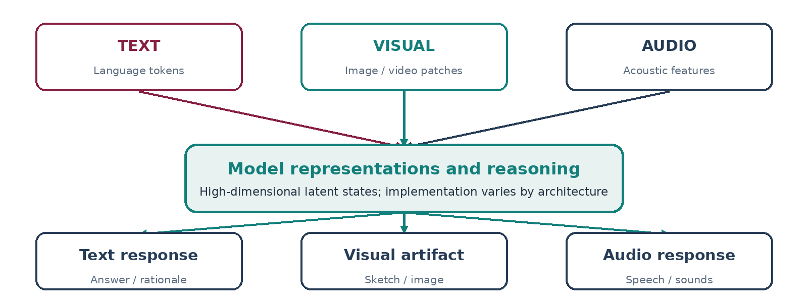
Figure 1: Conceptual multimodal architecture and shared internal representations
The diagram summarizes possible information pathways rather than the literal topology of every model. In particular, a system can accept images without generating its intermediate reasoning as images. OpenAI's GPT-4o system card describes end-to-end multimodal processing of audio, vision, and text. OpenAI also described image manipulation during reasoning in its 2025 o3 and o4-mini systems, including crop, zoom, and rotation operations. Those historical demonstrations do not imply that private visual activations or raw reasoning tokens are available through a public API.
A useful distinction is between three broad approaches:
- Text-based reasoning over multimodal inputs. A vision-language model receives an image, then produces or internally uses linguistic intermediate representations. A textual explanation may omit visual information or misstate which regions were examined.
- Interleaved visual and textual reasoning. An agent renders a figure or edits an image, inspects that resulting artifact, and uses it as input to a subsequent decision. Intermediate steps can be externally observed when the tools are instrumented.
- Latent multimodal reasoning. Intermediate states remain in vectors or learned tokens associated with visual features. Specialized decoders, activation probes, or model instrumentation are required to inspect them, and a visualization of those states may not be uniquely determined.
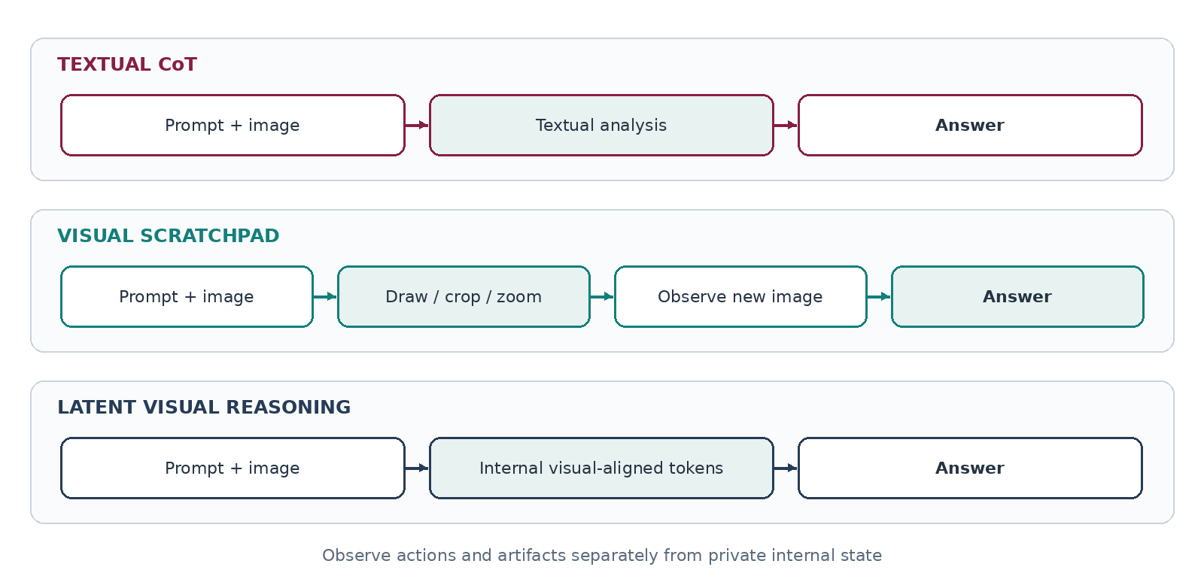
Figure 2: Comparison of text-based, interleaved visual, and latent multimodal reasoning
The categories overlap. A single workflow may use latent image features to identify an object, generate a textual plan, render a diagram, and inspect the diagram before producing an answer. For reproducible analysis, each step should retain its modality, provenance, and relationship to surrounding events.

Audio reasoning is a related but separate question
Audio models can preserve timing, pitch, rhythm, and vocal characteristics in representations that go beyond a transcript. Qwen2.5-Omni illustrates this design space with its Thinker–Talker architecture: its Thinker integrates multimodal inputs while the Talker generates speech. That architecture supports rich acoustic processing. It does not establish that audio models expose a human-readable auditory chain-of-thought analogous to an annotated sequence of images. This review therefore centers on visual reasoning, while treating audio as a relevant future modality.

Research on External Visual Reasoning Artifacts
External visual scratchpads are the most practical starting point for observing machine-produced visual reasoning. The agent calls a drawing, cropping, plotting, or simulation tool, receives a visual result, and continues. A trace can preserve each tool request and image. This approach gives researchers direct evidence that an artifact was produced and made available to the model; causal use still requires an intervention test.

Whiteboard-of-Thought
Menon, Zemel, and Vondrick's *Whiteboard-of-Thought: Thinking Step-by-Step Across Modalities* (EMNLP 2024) uses code-based drawing as an intermediate reasoning action. A model creates a visual representation using a graphics library, receives the rendered image, and continues solving the problem. The authors reported strong improvements in particular settings, including tasks where a tested text-only prompting condition scored zero and the whiteboard approach reached as high as 92%. Those values describe selected benchmark conditions, not a general 92% accuracy guarantee. The method is attractive because rendered images and the code that produced them can be archived and replayed.

Visual Sketchpad
Hu and colleagues' *Visual Sketchpad: Sketching as a Visual Chain of Thought for Multimodal Language Models* (NeurIPS 2024) extends the tool concept to sketches, lines, boxes, crops, and other image operations. The project reports average gains of 12.7% on studied mathematical problems and 8.6% on evaluated vision tasks. Its strongest contribution to this whitepaper is the explicit observe–act–observe structure: the agent manipulates a visual state and then re-reads the modified artifact.
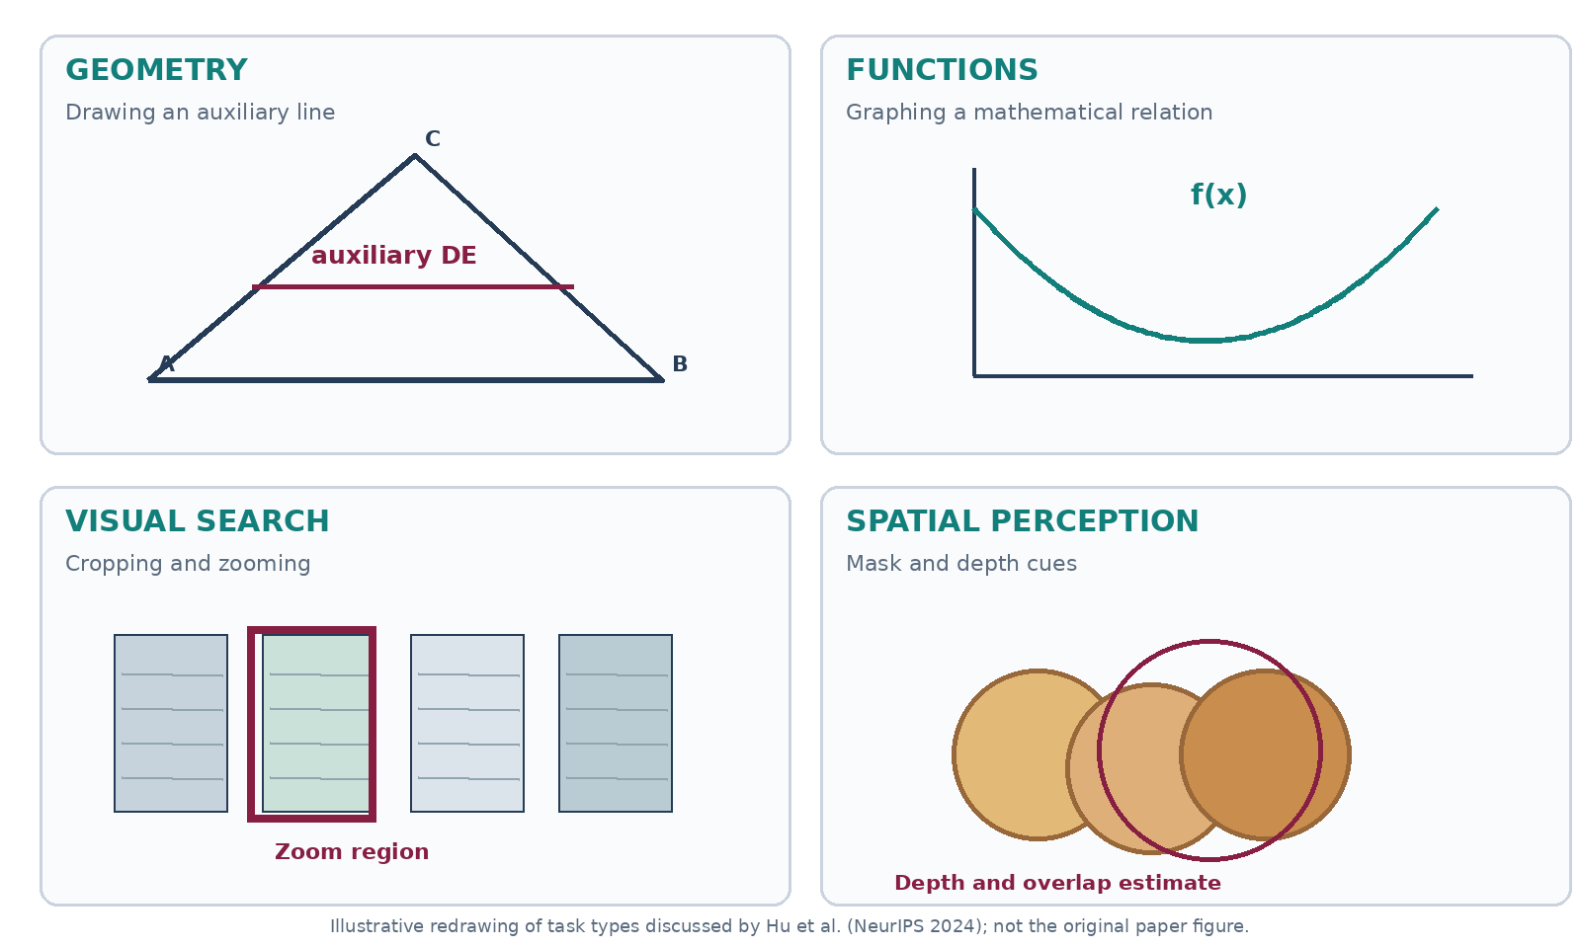
Figure 3: Illustrative examples of geometry, function plotting, visual search, and spatial perception
This is an original illustrative reconstruction of the categories of visual operations described by the paper, not its original research figure. The Visual Sketchpad project includes demonstrations, and the authors' source teaser figure provides the authentic visual example. The source link is retained because it is preferable to mislabel a reconstruction as a published figure.
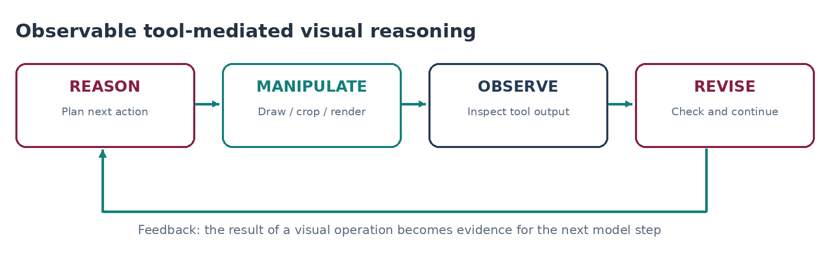
Figure 4: Observable loop from reasoning through a visual operation and back to interpretation
For a reasoning interface, the critical records are the tool call, its visual arguments, its output image, and the subsequent model invocation. A generated diagram that is never returned to the model belongs to a different class: an explanatory artifact created for the user.

Multimodal Visualization-of-Thought
Li and colleagues' *Imagine While Reasoning in Space: Multimodal Visualization-of-Thought* (ICML 2025) studies sequences that interleave language and generated visual states. This moves visual reasoning beyond drawing tools controlled by a text model. The MVoT research implementation is particularly relevant to experiments that compare explicit images and textual intermediates. The reported improvements concentrate on tasks where intermediate spatial visualization is useful; a deployment study would still need to test generalization to other task families.
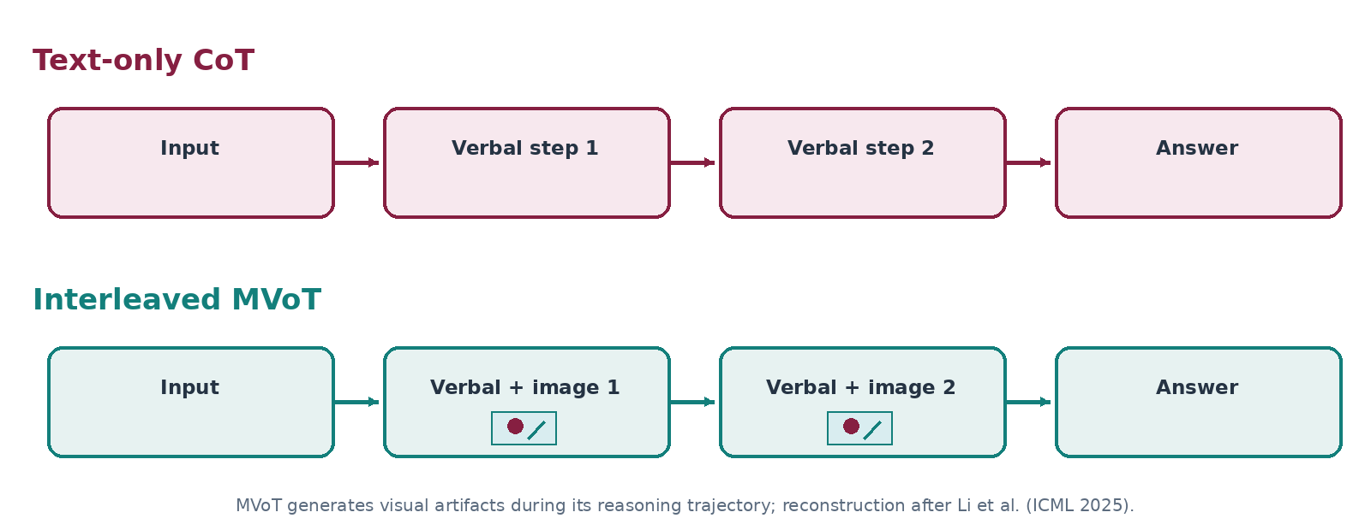
Figure 5: Illustrative timeline interleaving written observations and intermediate visual states

Image-only visual planning
The ICLR 2026 paper *Visual Planning: Let's Think Only with Images* investigates successive visual planning states in environments such as navigation and manipulation benchmarks. The researchers released code and model checkpoints. This is evidence that visual-state trajectories can be useful as intermediate planning representations under suitable training and benchmark conditions. It does not establish that all multimodal foundation models reason with internal images or can expose those images directly.
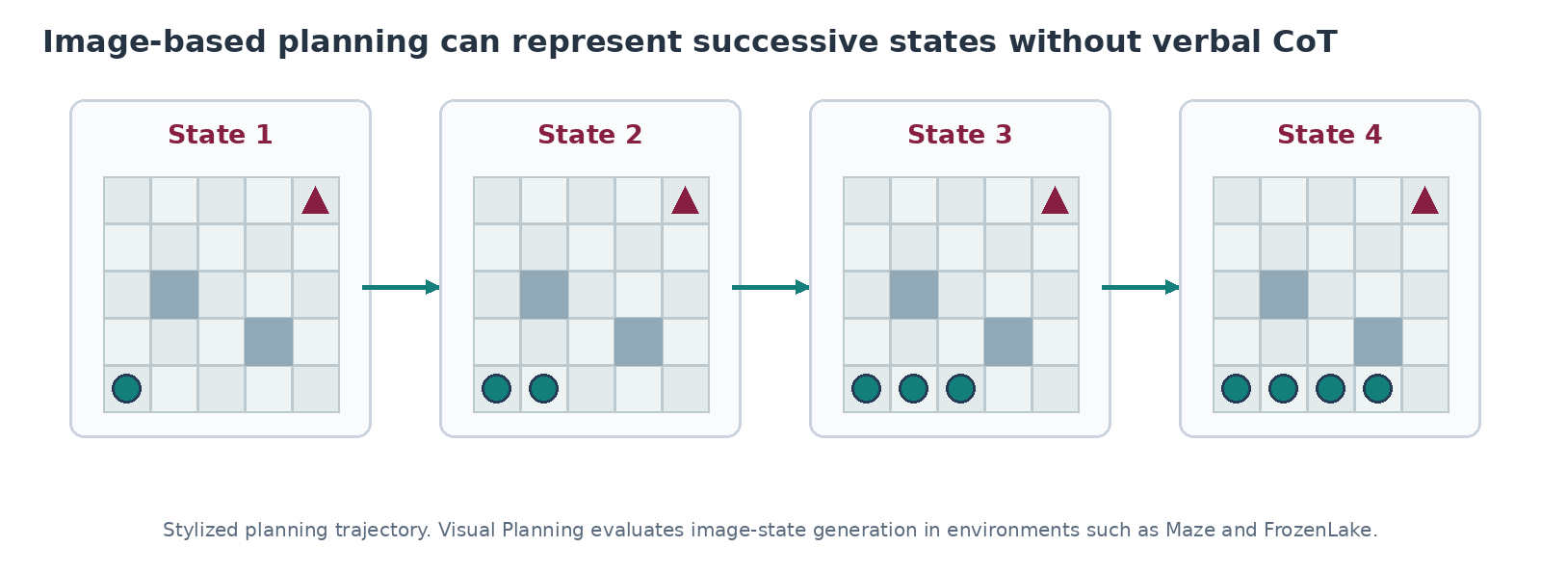
Figure 6: Illustrative sequential visual planning states in a grid navigation problem

Comparison of externally visible approaches
Research system | Intermediate artifact | What a researcher can observe | Important limitation
Whiteboard-of-Thought | Rendered drawings created by executable code | Tool code, drawing, and later response | Gains are task-specific
Visual Sketchpad | Cropped, annotated, or newly drawn images | Image operations and returned results | A trace alone cannot prove causal reliance
MVoT | Interleaved generated visual states | Generated images and accompanying language | Requires research-model implementation
Visual Planning | Image-based planning trajectory | Sequence of intermediate visual states | Trained and evaluated in defined environments

Research on Native and Latent Visual Reasoning
Some research tries to introduce multimodal reasoning into the model's generation or hidden-state sequence rather than relying on an external drawing tool. The resulting traces are more difficult to render faithfully, but these approaches are central to the question of whether a model can 'think visually.'

Text–visual interleaving within the model
TVI-CoT (ICML 2026) introduces learned control tokens to manage transitions between thinking, examining visual features, and answering. It reports improvements over the authors' baseline on multimodal-understanding benchmarks. Although a system can log a switch to image features, the switch itself does not necessarily yield a new human-readable picture. The model's effective visual observation may remain encoded in feature vectors.

Vision-aligned latent reasoning
Vision-aligned Latent Reasoning (ICML 2026) explores latent intermediate states aligned with visual perception. The authors report an improvement on VSI-Bench from 33.0% to 52.9% compared with the specified Qwen2.5-VL baseline. That result is informative for spatial reasoning, but these percentages should not be treated as a direct comparison with Whiteboard-of-Thought or any other different model/benchmark combination. Latent states are not inherently accessible through standard hosted inference APIs.
Mull-Tokens (CVPR Findings 2026) investigates intermediate, modality-agnostic tokens. It provides a technical route for reasoning that does not require each intermediate step to be emitted as ordinary text or a pixel image. The authors also report that forcing visual intermediates can reduce performance in some settings. This supports a modality-selection hypothesis rather than an 'always visualize' rule.
Chain-of-Visual-Thought (CoVT) investigates continuous visual representations for attributes such as depth, segmentation, and edges, with optional mechanisms for decoding or displaying intermediates. Such decoded outputs require care: a displayed depth map may represent one aspect of the latent state without constituting the model's full reasoning process.

Render-of-Thought
Render-of-Thought (ACL 2026) takes another route: it renders textual reasoning into images and uses image-aligned representations. The authors report three- to four-fold token compression in studied settings and publish a research implementation. This technique tests compact visual representation of reasoning text; it should not be conflated with spatial drawings invented during problem solving.
Latent or native approach | Claimed mechanism | Directly readable as images?
TVI-CoT | Learned switches between text reasoning and image features | Usually no; feature access requires instrumentation
Vision-aligned Latent Reasoning | Vision-aligned intermediate tokens | No; interpretation requires probes or decoders
Mull-Tokens | Modality-agnostic latent thinking | No canonical image rendering
CoVT | Continuous visual feature tokens | Some visual attributes can be decoded
Render-of-Thought | Text rendered as image-based intermediate representation | Rendered text image, not a spatial scene

What the Empirical Evidence Supports
Visual CoT offers measurable benefits in several task families. It also introduces overhead and can encourage redundant or misleading artifacts. The generalization claim depends on the benchmark, modality, model, and baseline.

Performance improvements in visual tasks
The CVPR 2026 benchmark paper *When Visualizing is the First Step to Reasoning: MIRA* evaluates 546 problems with visual intermediate requirements. In the reported experiments, supplying intermediate visual cues produced an average relative improvement of 33.7%. Because the model received external cues, the result establishes the usefulness of visual support more directly than it establishes an ability to invent such cues autonomously.
The 2026 workshop paper *Thinking in Pictures* investigates 1,200 examples across four vision-language models and several task categories. It reports improvements as high as 23.1% for visual CoT on selected settings; textual CoT can impair spatial performance. A strategy that adaptively selected textual or visual reasoning achieved 73.1% accuracy, compared with 68.9% for an always-visual approach in the reported evaluation. The findings motivate conditional use of visual thought.

More verbal reasoning can hurt spatial inference
Chain-of-Thought Degrades Visual Spatial Reasoning Capabilities of Multimodal LLMs (ACL 2026) examines 16 models across 13 spatial benchmarks and finds that adding textual CoT can degrade performance. Look Light, Think Heavy (ACL 2026) identifies an associated failure pattern: some systems increase verbal reflection while giving less weight to visual evidence. Neither study establishes that textual CoT is universally harmful; both indicate that extra text does not reliably substitute for re-examining the image.

Intermediate images may be incidental
The ICML 2026 position paper *Your VLM May Not Be Thinking with Interleaved Images* tests the causal contribution of intermediate images. The authors report cases in which training or generating visual intermediates appears beneficial while the images themselves contribute little to the final decision when subjected to intervention tests. This is the central methodological warning for a visual reasoning interface. A model-generated image can be an execution artifact, an aid to human understanding, or a causal input to later reasoning. Those categories cannot be inferred from appearance alone.

Synthesis of findings
Finding | Evidence | Research implication
Visual intermediates can help spatial reasoning | MIRA; Whiteboard-of-Thought; Visual Sketchpad | Evaluate on tasks with explicit visual operations
Modality choice matters | Thinking in Pictures; Mull-Tokens | Compare adaptive routing with always-visual prompting
Verbose textual thought can interfere | ACL spatial CoT study; Look Light, Think Heavy | Measure performance as well as explanation length
Images may be noncausal | Your VLM May Not Be Thinking with Interleaved Images | Remove or replace intermediate images during evaluation
Latent traces remain difficult to interpret | TVI-CoT; vision-aligned latent work; CoVT | Separate decoded features from raw model states

Can Existing Products Expose Visual Thinking?
The term expose must be defined before comparing tools. Hosted APIs may reveal the prompt, selected reasoning summaries, tool requests, and output attachments. Open-weight models may additionally permit access to hidden states, attention tensors, or generated visual tokens. Observability platforms organize these events into timelines. None of these capabilities automatically gives a complete, causally faithful account of the model's private computation.
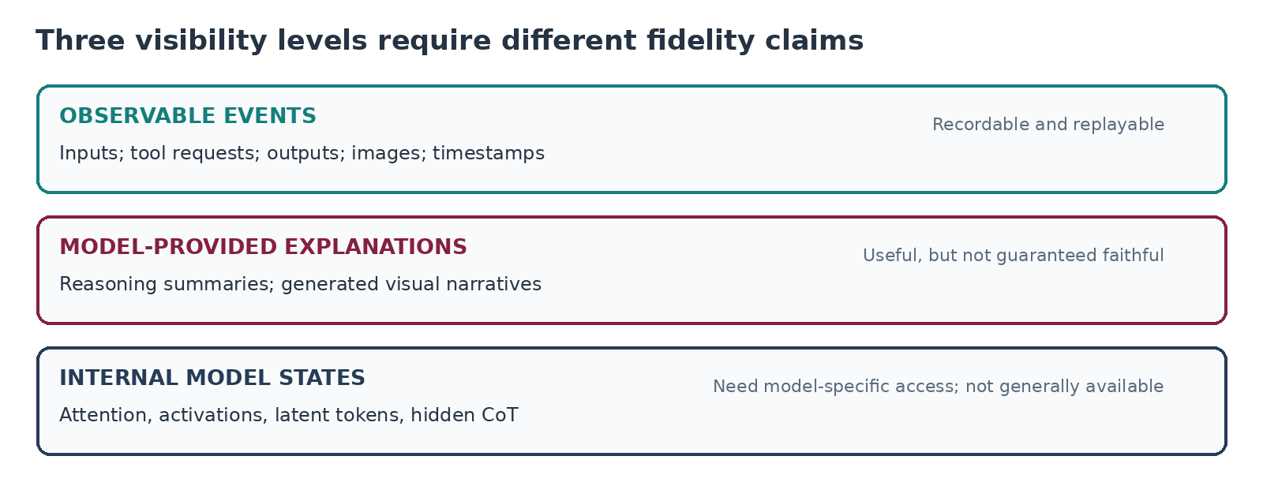
Figure 7: Layers of observable evidence from tool events through latent representations

Hosted model interfaces and research-model access
OpenAI Responses API. The OpenAI reasoning guide describes reasoning-model behavior and supported reasoning summaries. Raw hidden reasoning tokens are not returned. An application can capture visible tool calls and resulting images when those tool operations are executed through the application or instrumented provider interfaces. An answer accompanied by a model-produced diagram should therefore be represented as a generated explanation unless the diagram was demonstrably used in a subsequent model invocation.
Google Gemini API. Google's thinking documentation describes model thinking-related functionality. In its Interactions API, optional thought-summary content can include text and image parts; availability and completeness depend on the interaction and model. Encrypted thought signatures serve a different role from readable traces. The interface does not promise access to internal visual latents.
Qwen3-VL and research checkpoints. The Qwen3-VL repository makes open-weight thinking-oriented models and relevant examples available. Depending on the selected checkpoint and serving stack, researchers can instrument tool-based zoom/crop operations and may inspect internal activations. MVoT, Visual Planning, and CoVT offer more targeted mechanisms for studying intermediate images or continuous visual tokens. Their research workflows are not equivalent to a stable, hosted commercial API.
Interface | Visible text reasoning | Visible intermediate images | Hidden-state access
OpenAI Responses | Summaries when supported | Images and tool artifacts captured by workflow | No raw hidden reasoning API
Gemini thinking / Interactions | Optional thought summaries | Optional image parts in supported summaries | No general raw latent export
Qwen3-VL | Checkpoint and serving dependent | Tools and custom model instrumentation | Potentially, with weights and runtime control
Visual Planning | Not its central representation | Planning image sequence in research environment | Depends on local research stack
CoVT | Implementation dependent | Optional decoded visual features | Yes, when run locally and instrumented

Langfuse
Langfuse multimodal observability supports traces containing image or audio attachments alongside prompts, tool outputs, and usage information. It is a practical repository for visual artifacts and cross-step provenance. Langfuse logs observable events; it cannot retroactively retrieve hidden model thoughts from a hosted API.
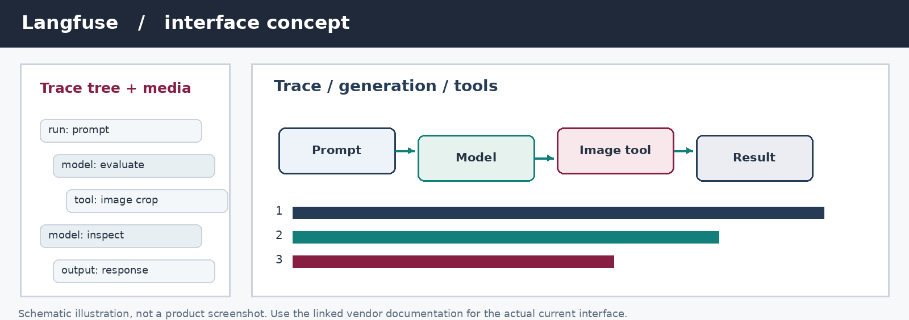
Figure 8: Illustrative Langfuse-style multimodal trace with linked media attachments
The figure is an original interface schematic based on documented capabilities, not a captured Langfuse product screenshot.

LangSmith
LangSmith observability records model invocations, tool spans, nested runs, and attached multimodal inputs or outputs. It is useful when an experiment needs synchronized evaluation results and tool-execution history. Visual artifacts can be attached to individual runs, although causal interpretation still depends on the experiment design.
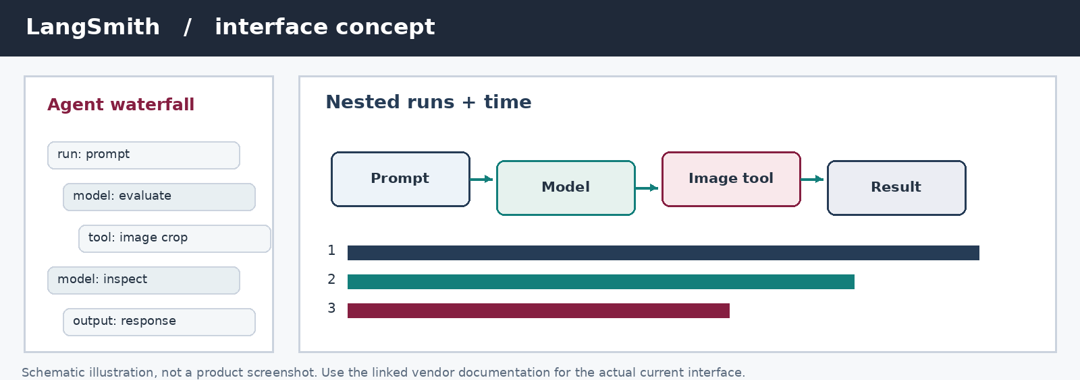
Figure 9: Illustrative LangSmith-style nested trace with model and tool spans
The figure is an original schematic of observable tracing concepts, not a captured LangSmith screenshot.

OpenAI Agents tracing
The OpenAI Agents SDK tracing documentation describes recorded spans for model generation, tool calls, handoffs, and other agent activities. This supports a timeline of externally visible execution. It does not convert private reasoning tokens into a disclosed chain-of-thought.
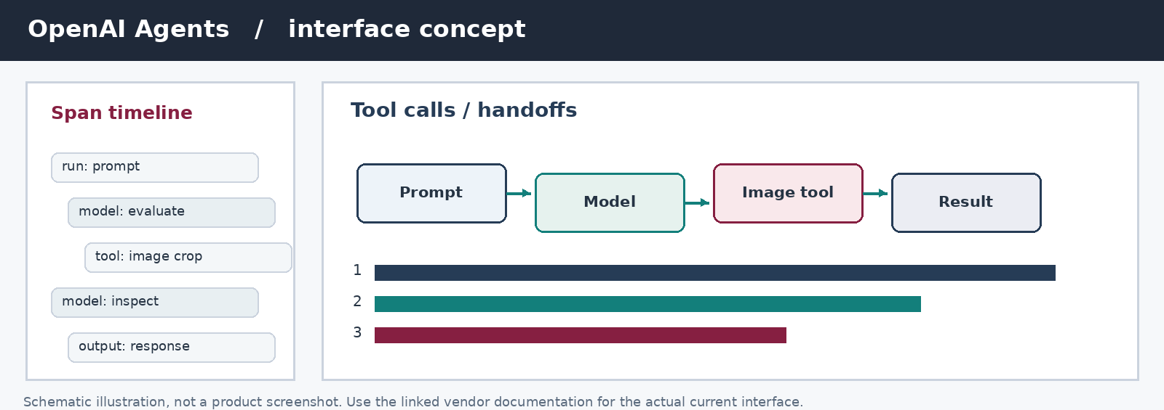
Figure 10: Illustrative OpenAI Agents-style execution trace with tool events
The figure is an original schematic of documented tracing capabilities, not a product screenshot.

Visualizing internal features: VL-InterpreT
IntelLabs' VL-InterpreT supports inspection of cross-modal attention and related hidden representations in compatible models. The newer LVLM-Interpret project expands interpretability work for large vision-language models. Heatmaps can guide exploratory analysis. Their colors and highlighted regions should not be described as proof that a feature caused a model decision without an intervention or other suitable validation.
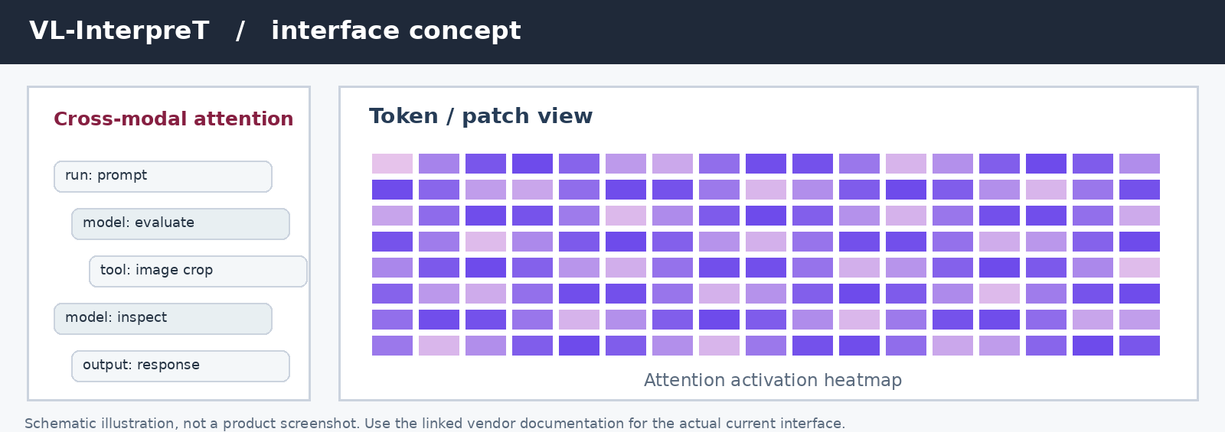
Figure 11: Illustrative cross-modal attention heatmap and token-to-image view
The figure is a schematic of interpretability visualization, not a screenshot or a measured attention map from a deployed model.

Proposed Architecture: A Synchronized Visual Reasoning Workspace
An experimental Space to Think interface can combine model-visible text, images, tool events, and provenance in a single replayable timeline. The architecture should preserve observed facts independently of generated explanations. It also needs to distinguish external artifacts, summaries of private reasoning, and reconstructed or decoded hidden states.
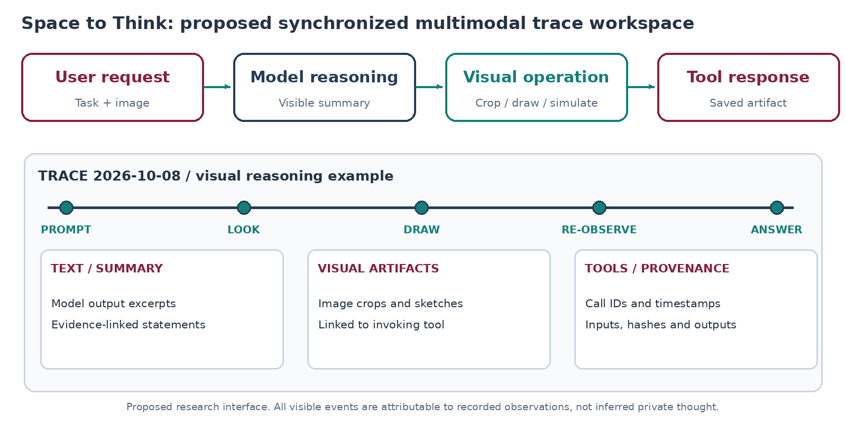
Figure 12: Conceptual Space to Think synchronized multimodal reasoning workspace
A minimal architecture contains four subsystems: an instrumented model gateway that records requests and visible responses; an artifact service that stores originals and derived visual media; a trace store for events and parent–child relations; and a viewer that aligns text, tool operations, images, and evidence. A visual scratchpad can be implemented as a drawing, crop, chart, or simulation tool and inserted into the model's regular tool-calling cycle. Logging should occur before and after every external operation.

Proposed trace event schema
The following fields are a suggested research schema rather than an existing universal API:
{
"event_id": "evt-004", "parent_event_id": "evt-003", "sequence": 4,
"event_type": "tool_result", "modality": "image",
"source_kind": "observed_tool_artifact", "tool_name": "sketchpad.draw",
"artifact_uri": "artifacts/session-001/sketch-004.png",
"input_hash": "sha256:<input-digest>", "model_id": "model-v1",
"timestamp_utc": "2026-10-08T17:00:00Z"
}

The schema should support replay, source attribution, and comparisons across experimental conditions. Store tool input arguments, generated output hashes, and the exact model version separately. The visible interface should label observed tool artifacts as such; if a model merely describes an image it might have considered, the system should not silently create a corresponding observed-image event.

Evidence labeling
Label in the interface | Meaning | Typical source
Observed input | Material supplied to the model or tool | Uploaded image; retrieved page
Observed tool operation | Invocation executed outside the model | Crop; draw; graph; simulation
Observed visual artifact | Tool or model output saved during execution | Returned crop; intermediate sketch
Model-visible summary | Provider-available explanatory or reasoning summary | Optional reasoning-summary output
Generated explanation | Visual/textual narrative created to explain a result | Diagram produced after answer
Decoded representation | Model state interpreted by a researcher-built decoder | Feature map; latent probe

The distinction is more than terminology. A user-facing display can otherwise turn uncertain interpretability evidence into a confident account of 'what the model thought.' The interface should allow users to inspect the source event, exact tool arguments, and whether the model observed the artifact before its answer.

Proposed Experimental Design
The most accessible initial study uses a vision-capable model with a controlled visual scratchpad and task sets that require image-based reasoning. The design tests whether intermediate visual operations improve problem-solving performance, whether the model causally uses those operations, and whether their display helps people evaluate and steer the system.

Research questions
RQ1: Task performance. Under what conditions do intermediate visual operations improve task accuracy compared with direct answering and textual reasoning?
RQ2: Causal reliance. When a system produces intermediate drawings or crops, do changes to those artifacts alter its subsequent decisions?
RQ3: Human understanding. Does a synchronized text–image–tool trace help users identify errors, assess confidence, and choose productive interventions compared with a conventional chat transcript?

Controlled conditions
Condition | Description | Interpretation
C0: Direct response | Model answers without an explicit reasoning scratchpad | Baseline performance
C1: Textual reasoning | Model is instructed to reason through linguistic steps where available | Tests value or cost of text focus
C2: Post-hoc visualization | Model answers first, then draws an explanatory diagram | Tests explanation value only
C3: Active visual scratchpad | Model creates and re-observes intermediate visual artifacts | Tests visual feedback contribution
C4: Specialized visual model | Optional MVoT, Visual Planning, or CoVT deployment | Tests native visual intermediate mechanisms

Use equal task samples, consistent model families where possible, and matched compute/time budgets. When specialized models have different capabilities, analyze them separately rather than attributing all performance differences to the presence of visual reasoning.

Causal tests and logging
Causal reliance requires interventions. For a subset of tasks in C3, the study should remove an intermediate image, replace it with an unrelated but format-compatible image, or swap a drawing with another sample's artifact. The next model invocation must be otherwise held constant. Measure whether the response changes, whether accuracy drops, and whether the model notices the inconsistency. Store the intervention identity as a distinct trace event to make the experimental manipulation auditable.
Candidate tasks include spatial transformations and object tracking, geometry with auxiliary drawings, visual search requiring crops, and image-based navigation. MIRA and related task families provide sources for benchmark selection. Before collecting results, establish task licensing, splits, scoring rules, and exclusions for ambiguous ground truth.

Measures
Primary task metrics should include exact or rubric-based accuracy, successful completion, visual-tool calls per problem, execution latency, generated tokens, and direct serving cost. Causal measures should include the accuracy change under image replacement/removal and the fraction of decisions that respond appropriately to visual perturbations. For a separate HCI assessment, use error-detection accuracy, confidence calibration, response time, and intervention quality. Evaluators should not assume that a more detailed visual trace necessarily improves human judgment.
[TODO: Select exact model checkpoints, dataset splits, inference endpoints, and the compute or financial budget before the experiment.]
[TODO: Specify participant recruitment, evaluation protocol, and any required institutional review or exemption before the proposed human study.]

Relationship to current HCI research
The IUI 2026 paper *Interactive Reasoning: Visualizing and Controlling Chain-of-Thought Reasoning in Large Language Models* presents Hippo, a hierarchy-oriented interface for reasoning inspection and steering. Its reported evaluation involved 16 participants. Hippo concerns accessible reasoning structure and interactive control rather than revealing private visual activations; its contribution provides an HCI point of comparison for the proposed synchronized multimodal interface. Existing agent observability tools address logging and debugging but do not by themselves answer whether humans form more accurate mental models of a multimodal assistant.

Limitations, Integrity, and Open Questions
Several limitations should govern interpretation of both the reviewed literature and new experiments.
Restricted access to private reasoning. Hosted providers can return reasoning summaries or selected events while retaining hidden model reasoning. No tool should claim to reconstruct internal visual thought from text summaries alone. Even with open weights, probe visualizations and attention maps require separate validation.
Benchmark-specific gains. Numeric results vary across models, training regimes, prompts, and task difficulty. A 33.7% relative improvement from supplied visual cues cannot be compared directly to the 12.7% gain reported for a tool-based scratchpad under different benchmarks and baselines. Relative percentages and absolute percentage-point gains have different meanings.
Explanation faithfulness. A visually coherent drawing may be produced for presentation, after the underlying decision, or without later model use. Recording the drawing does not verify a causal role. Perturbation tests and precise execution provenance are central to the methodology.
Cost and observability. External visual tools add model calls, image tokens, latency, and storage. Latent probes add instrumentation and reproducibility concerns. An adaptive modality selector should include these costs rather than evaluating accuracy alone.
Human interpretation risk. A dense multimodal trace may overload users or create unwarranted confidence. Interfaces should support progressive disclosure, direct artifact inspection, event provenance, and uncertainty labels. Research must evaluate comprehension empirically before asserting an HCI benefit.
Visual provenance and copyright. All figures supplied with this paper are original illustrative diagrams, not copied screenshots or reproduced publisher figures. Direct links to the original Visual Sketchpad figure, papers, and product documentation are provided. This distinction prevents an illustrative reconstruction from being mistaken for evidence of a real model execution.

Conclusion
Research published between 2024 and October 2026 establishes that intermediate visual operations can improve multimodal reasoning on tasks where images, spatial relationships, and changing scenes carry useful information. The performance benefit depends on the task and how the model uses the visual content. Some recent work shows that textual CoT can worsen spatial reasoning; other work demonstrates that a model may generate plausible visual steps without relying on them. Research on latent visual tokens provides further mechanisms, but standard hosted APIs rarely disclose those internal states.
A practical first step is to instrument a visual scratchpad and capture the resulting images together with model responses and tool execution. This supplies genuine observable artifacts, while intervention experiments test their causal relevance. A synchronized reasoning interface could then help people review those artifacts and identify errors, provided its design preserves the boundary between logged evidence, generated explanations, and interpreted model states. That boundary is central to a credible research program on multimodal reasoning transparency.

References and Direct Links
[1] Menon, S., Zemel, R., & Vondrick, C. (2024). Whiteboard-of-Thought: Thinking Step-by-Step Across Modalities. EMNLP 2024. DOI: 10.18653/v1/2024.emnlp-main.1117.
[2] Hu, Y., et al. (2024). Visual Sketchpad: Sketching as a Visual Chain of Thought for Multimodal Language Models. NeurIPS 2024. Project, demonstrations, original figures.
[3] Li, C., et al. (2025). Imagine While Reasoning in Space: Multimodal Visualization-of-Thought. ICML 2025. Code.
[4] Xu, Y., et al. (2026). Visual Planning: Let's Think Only with Images. ICLR 2026. Code and checkpoints.
[5] Hu, L., et al. (2026). TVI-CoT: Text-Visual Interleaved Chain-of-Thought Reasoning for Multimodal Understanding. ICML 2026.
[6] Jeon, B., et al. (2026). Vision-aligned Latent Reasoning for Multi-modal Large Language Model. ICML 2026.
[7] Ray, A., et al. (2026). Mull-Tokens: Modality-Agnostic Latent Thinking. CVPR Findings 2026.
[8] Chain-of-Visual-Thought (CoVT): continuous visual tokens. Research implementation and documentation, 2026.
[9] Wang, Y., et al. (2026). Render-of-Thought: Rendering Textual Chain-of-Thought as Images for Visual Latent Reasoning. ACL 2026. Code.
[10] Zhou, Y., et al. (2026). When Visualizing is the First Step to Reasoning: MIRA, a Benchmark for Visual Chain-of-Thought. CVPR 2026.
[11] Jenkins, B. (2026). Thinking in Pictures: A Diagnostic Study of Visual vs. Textual Chain-of-Thought Reasoning in Vision-Language Models. ACL ALVR Workshop 2026.
[12] Kancheti, S. S., et al. (2026). Chain-of-Thought Degrades Visual Spatial Reasoning Capabilities of Multimodal LLMs. ACL 2026 Short Papers.
[13] Jin, Z., et al. (2026). Look Light, Think Heavy: What Multimodal Chain-of-Thought Reasoning Can and Cannot Do. ACL 2026.
[14] Yang, W., Zhu, S., & Huang, Z. (2026). Position: Your VLM May Not Be Thinking with Interleaved Images. ICML 2026.
[15] Dong, Q., et al. (2026). Revealing the Seen, Imagining the Beyond: A Survey of Image-Grounded Chain-of-Thought Reasoning in Multimodal LLMs. ACL 2026. Curated papers and code.
[16] Interactive Reasoning: Visualizing and Controlling Chain-of-Thought Reasoning in Large Language Models (2026). ACM IUI 2026.
[17] OpenAI (2024). GPT-4o System Card.
[18] OpenAI (2025). Thinking with Images.
[19] Qwen2.5-Omni technical report (2025). Project description.
[20] OpenAI. Reasoning model guidance and Agents SDK tracing. Product documentation, accessed October 2026.
[21] Google. Gemini thinking and thought-summary documentation. Product documentation, accessed October 2026.
[22] Qwen team. Qwen3-VL open-weight model and examples. Software repository, accessed October 2026.
[23] Langfuse. Multimodal observability documentation. Product documentation, accessed October 2026.
[24] LangChain. LangSmith observability documentation. Product documentation, accessed October 2026.
[25] Intel Labs. VL-InterpreT and LVLM-Interpret. Open-source interpretability tools, accessed October 2026.

Appendix: Figure Sources and Reuse
The twelve embedded figures were prepared for this paper to illustrate model architectures, research operations, product observability, and a proposed reasoning workspace. They are not reproduced publisher figures or authenticated product screenshots. Their complete PNG files and figure manifest accompany the editable Markdown source package.
The original visual material for Visual Sketchpad can be reviewed in the authors' demonstration figure. The schematics of Langfuse, LangSmith, OpenAI Agents tracing, and VL-InterpreT should be compared with each project's current documentation before making product-specific implementation decisions.

